This document provides a guide for initializing a Git repository, establishing a project structure, and configuring GitHub branch protection:
- Workflow Setup: Covers the end-to-end process of creating directories, initializing Git, staging, committing, and pushing code to a remote GitHub repository.
- Branch Protection Troubleshooting: Details how to handle branch protection limitations on free private repositories by suggesting solutions like making the repository public, upgrading the account, or utilizing CI/CD status checks.
- Verification and Workflow: Explains how to test branch protection enforcement, set up pull request workflows, and work around approval restrictions when merging changes.

Git Basics for Beginners
Git is a version control system that helps you track changes to your source code and collaborate effectively with others. It allows you to revert files to previous states, review change history, and coordinate work across teams.

1. Installation and Configuration
Check if Git is already installed on your system by running the following command in your terminal or command prompt:

git --version
If Git is not installed, download and install it from the official website (git-scm.com).
Next, configure your identity so your commits are properly attributed to you:

git config --global user.name "Your Name"
git config --global user.email "your_email@example.com"

2. Creating a Repository
A Git repository stores all files and revision history for a project. You can either initialize a new repository locally or clone an existing one.

Initializing a New Repository

mkdir my_project
cd my_project
git init

Cloning an Existing Repository

git clone https://github.com/username/repository.git

3. Basic Git Workflow
Git manages files across four main areas:
- Working Directory: The local directory where you directly edit and create files.
- Staging Area (Index): A preview area where changes are organized before being committed.
- Local Repository: Your local copy of the repository storing all committed versions.
- Remote Repository: A server-hosted version (e.g., GitHub) used to collaborate with team members.

Staging and Committing Changes
To add specific modified files or all changes to the staging area:

# Stage a specific file
git add filename

# Stage all modified and new files
git add .
Save the staged snapshot to your local repository history using a descriptive commit message:

git commit -m "Add descriptive commit message here"

Synchronizing with Remote Repositories
Push your local commits to the remote repository:

git push origin main
Fetch and merge changes from the remote repository to update your local copy:

git pull origin main

4. Viewing History
To review the chronological log of commits in the repository:

git log


Git Repository Setup & Initial Deployment
Initialize a Git repository, create a directory structure, and push your work to a remote repository using Git Bash, follow these steps:

1. Create and Enter Directory
Start by creating your project folder and navigating into it:
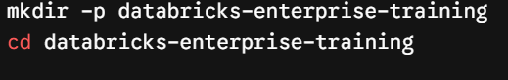
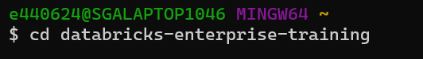

mkdir -p databricks-enterprise-training
cd databricks-enterprise-training


2. Initialize Git
Turn the current directory into a Git repository:

git init

3. Establish Project Structure
Create the necessary subdirectories for your project (e.g., config, utils, and source folders):
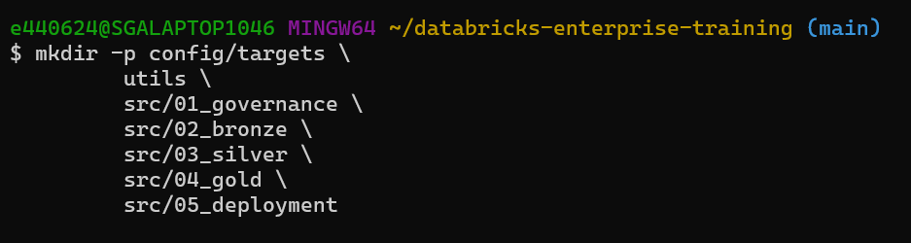

mkdir -p config/targets \
utils \
src/01_governance \
src/02_bronze \
src/03_silver \
src/04_gold \
src/05_deployment

4. Create Placeholder Files
Use the touch command to create empty files where your code or configuration will go, ensuring the structure is ready:
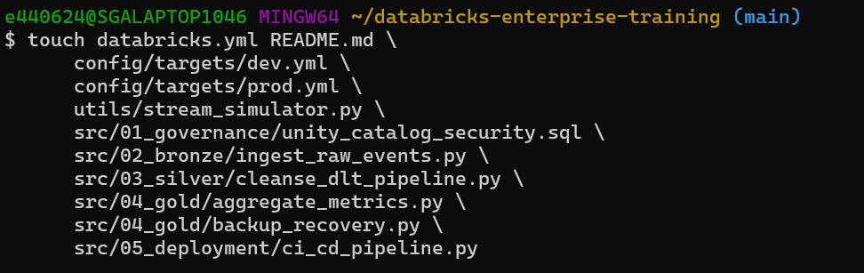

touch databricks.yml README.md \
config/targets/dev.yml \
config/targets/prod.yml \
utils/stream_simulator.py \
src/01_governance/unity_catalog_security.sql \
src/02_bronze/ingest_raw_events.py \
src/03_silver/cleanse_dlt_pipeline.py \
src/04_gold/aggregate_metrics.py \
src/04_gold/backup_recovery.py \
src/05_deployment/ci_cd_pipeline.py

Verify the Structure
Confirm your directory tree looks correct before committing:
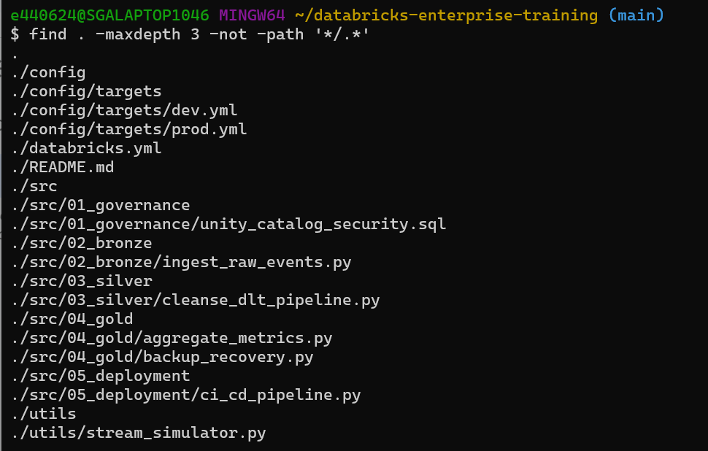

find . -maxdepth 3 -not -path '*/*.*'

5. Stage and Commit
Add all files to the staging area and create your initial commit:
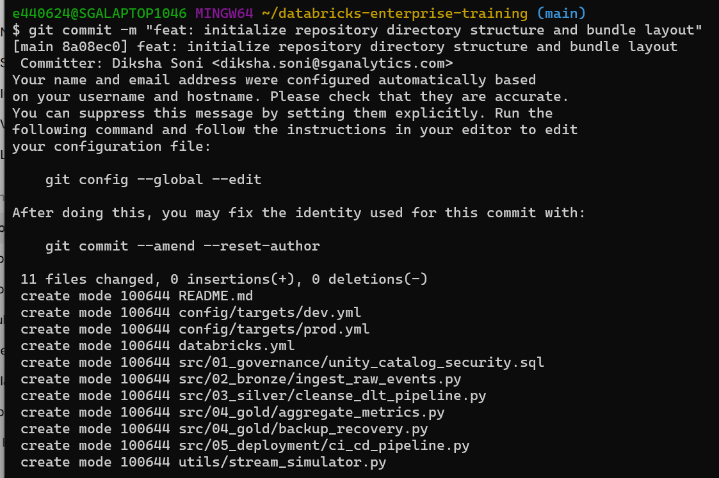

git add .
git commit -m "feat: initialize repository directory structure and bundle layout"

6. Set Branch and Remote
Ensure your default branch is named main and link your local repository to your remote GitHub repository:

git branch -M main

7. Link Remote Repository
Link your GitHub remote repository (Replace with your actual repo URL):

git remote add origin https://github.com/sga-databricks-lab/databricks-enterprise-training.git

8. Push to Remote
Finally, upload your local changes to the remote main branch:
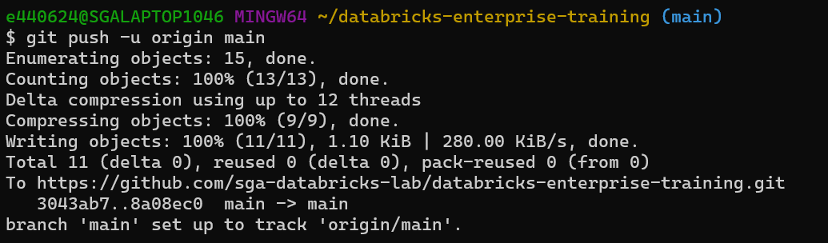

git push -u origin main

9. Clean Up Temporary Files
If you need to clean up temporary files like .gitkeep later, you can remove them using git rm (e.g., git rm config/.gitkeep or find config utils src -name ".gitkeep" -exec git rm {} +) and commit those changes afterward.
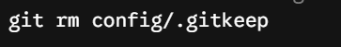
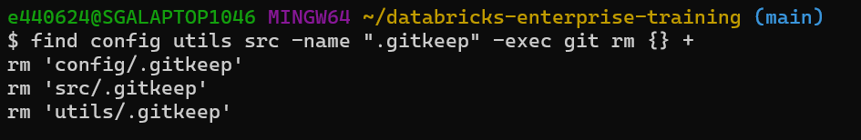

git rm config/.gitkeep
find config utils src -name ".gitkeep" -exec git rm {} +

10. Push into main origin
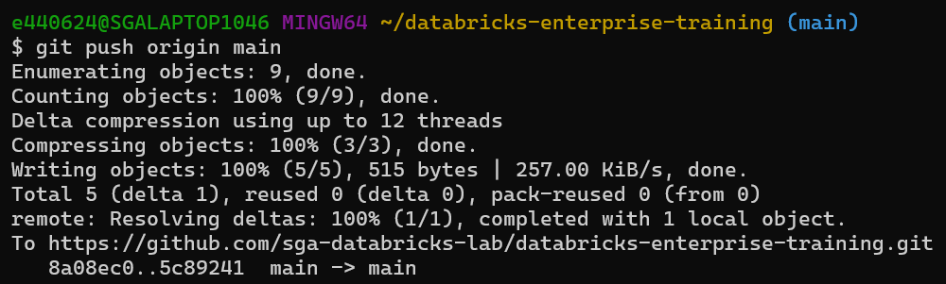

git push origin main
By default, GitHub does not protect the main branch automatically—anyone with write access can push code directly to it.
To enable branch protection with your exact requirements, follow these steps in your repository settings:

Step 1: Open Branch Protection Settings
- Go to your repository on GitHub.
- Click on Settings in the top navigation bar.
- In the left sidebar, click Branches.
- Click Add branch protection rule (or Add rule).

Step 2: Apply Your Protection Checks
- Branch name pattern: Enter main.
- Check Require a pull request before merging:
  - Set Required approvals to 1.
  - Check Dismiss stale pull request approvals when new commits are pushed.
  - Check Require approval of the most recent reviewable push.
- Check Require status checks to pass before merging:
  - Check Require branches to be up to date before merging.
  - Select your repository's active CI/CD checks from the list.
- Check Require conversation resolution before merging.
- Check Do not allow bypassing the above settings (or Include administrators depending on your GitHub plan). This prevents admin overrides.
- Ensure Allow force pushes remain unchecked (force pushes are blocked by default once protection is enabled).

Step 3: Save Changes
Click Create or Save changes at the bottom of the page.
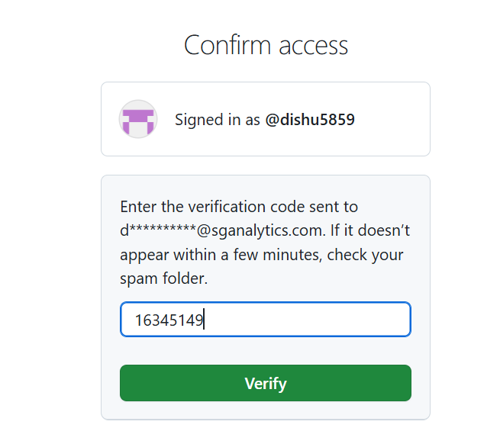
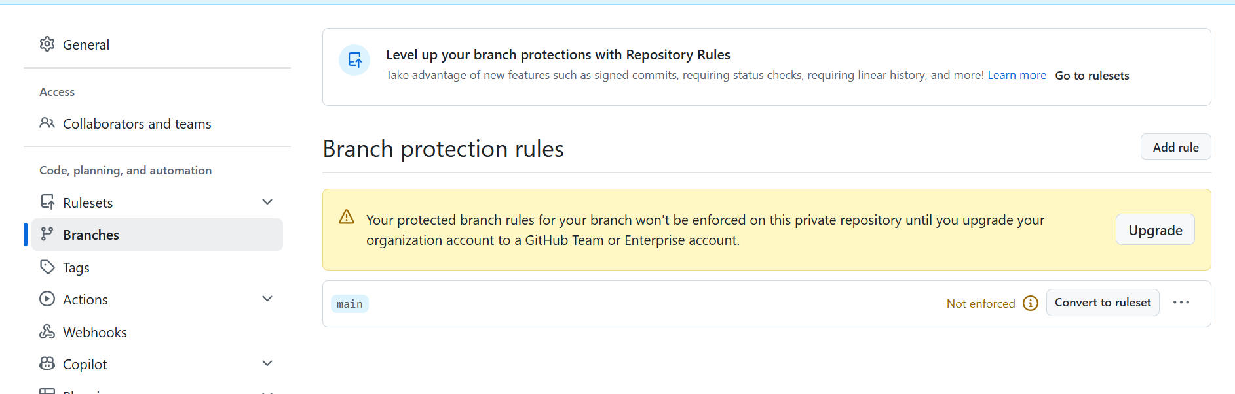

Option 1: Make the Repository Public (Free Solution)
- If the code is not confidential, change the repository visibility to Public.
- On public repositories, all Branch Protection Rules are enforced completely free, even on the GitHub Free plan.
- Steps: Repo Settings -> General -> scroll down to Danger Zone -> Change visibility -> Make public.

Option 2: Upgrade the Account (Paid Solution)
- If keeping the repository private is essential, you will need to upgrade your organization account to a GitHub Team or Enterprise plan (by clicking the Upgrade button shown in the screenshot).

Option 3: GitHub Actions CI/CD (Free Workaround for Private Repos)
- Without rules enforcement, direct pushes won't be hard-blocked, but you can enforce status checks using a GitHub Actions workflow so that PRs cannot be merged if checks fail.
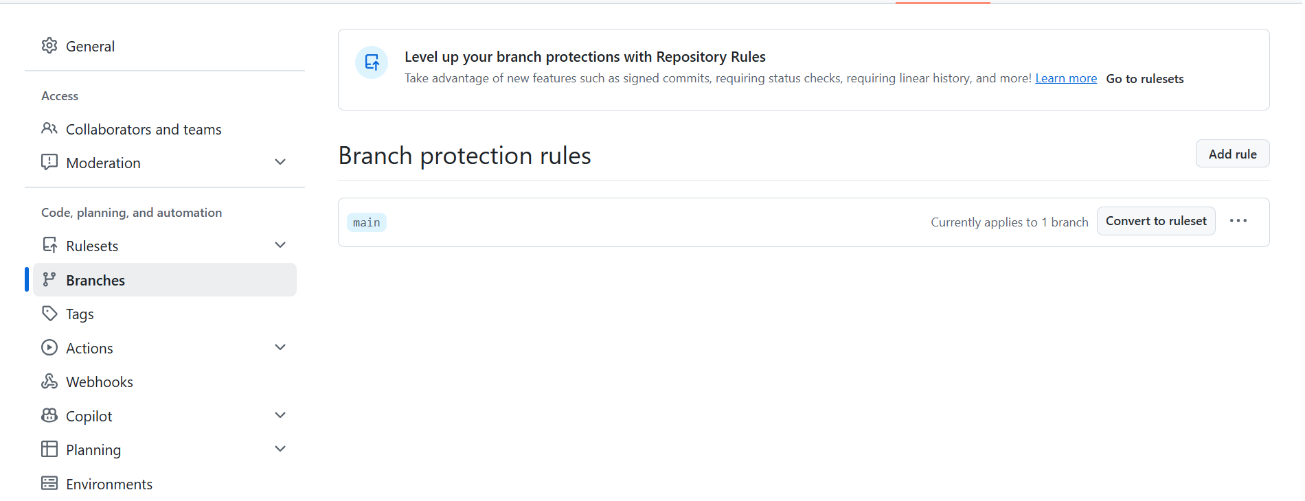
Your Branch Protection rule has been successfully activated (it shows "Currently applies to 1 branch" and the warning has disappeared).

To verify, test the following:
- Direct Push Test: Try to push directly to the main branch in your local terminal (git push origin main). GitHub will reject it: GH006: Protected branch hook declined.

git push origin main
- Pull Request Workflow: Now, to push any changes, you will need to create a feature branch, open a pull request, get 1 review approval, and all conversations must be resolved before code can be merged into main.

Step-by-step Approval Process:
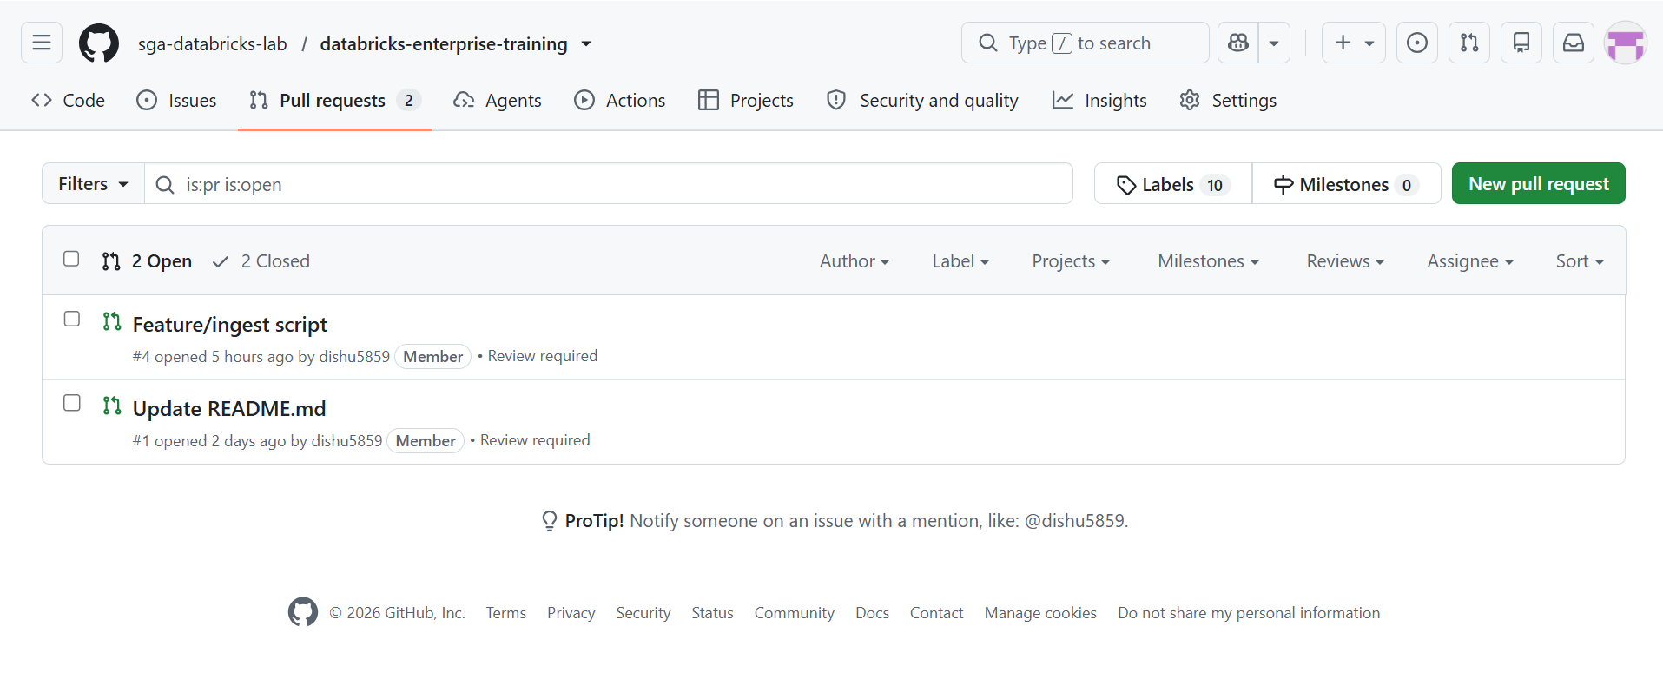
- Open the PR: Click on a PR from the list (for example, Update README.md #1).
- Go to the Files Changed Tab: Click on the Files changed tab at the top of the page.
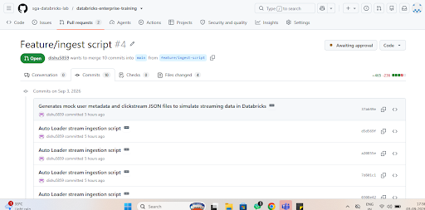
- Click the Review Changes Button: Click the green Review changes button located in the upper right corner.
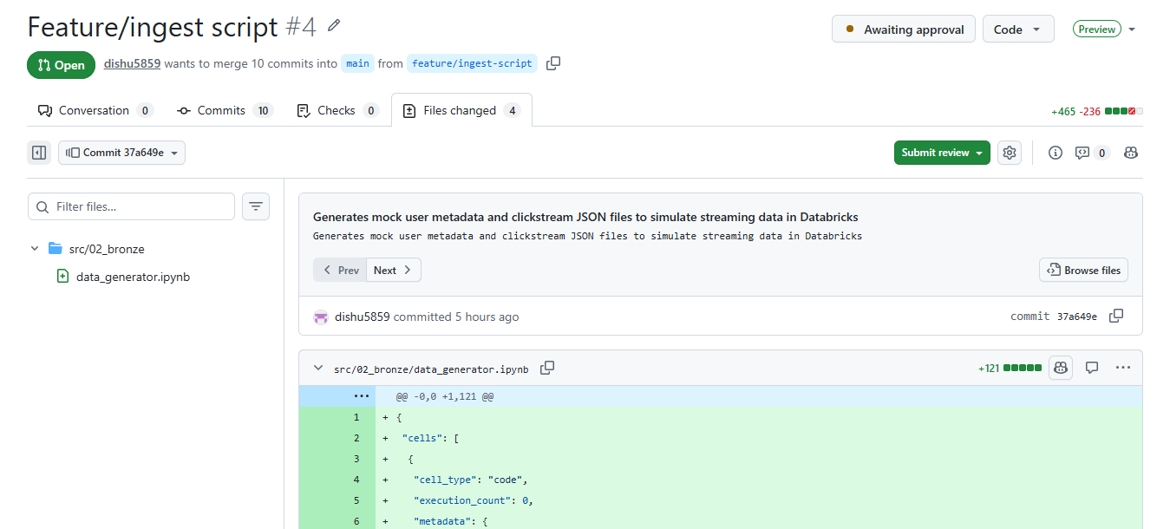
- Select Approve: In the dropdown menu that appears:
  - Select the Approve radio button.
  - Click the green Submit review button.
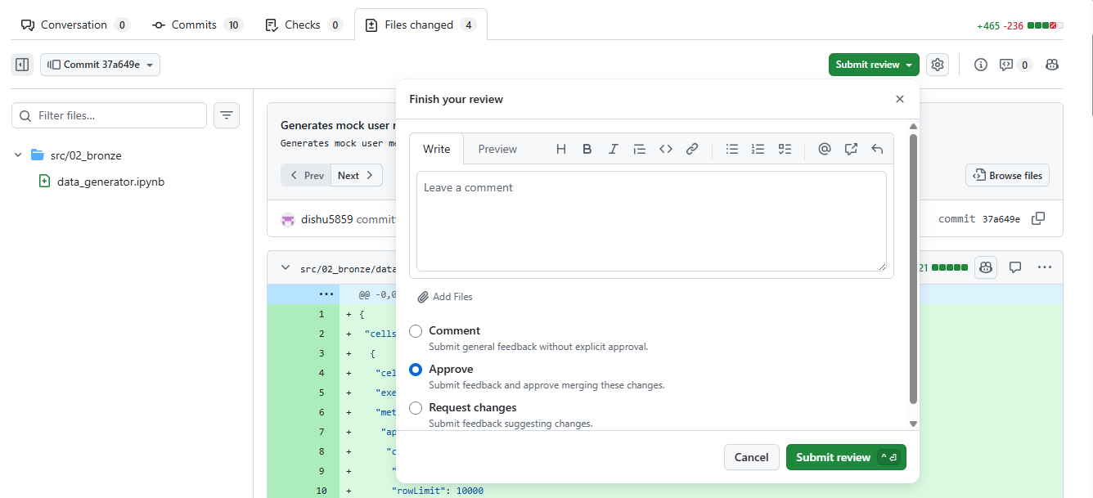
- Select Merger Pull Request: In the dropdown menu that appears:
  - Select the Approve radio button.
  - Click the green Merger Pull request button.
  - Confirm Merger.
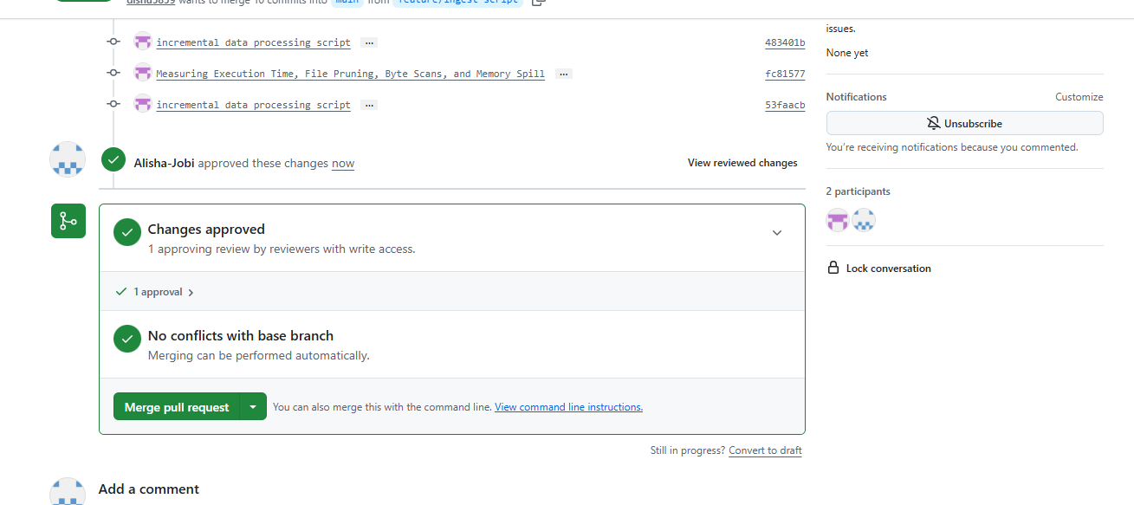
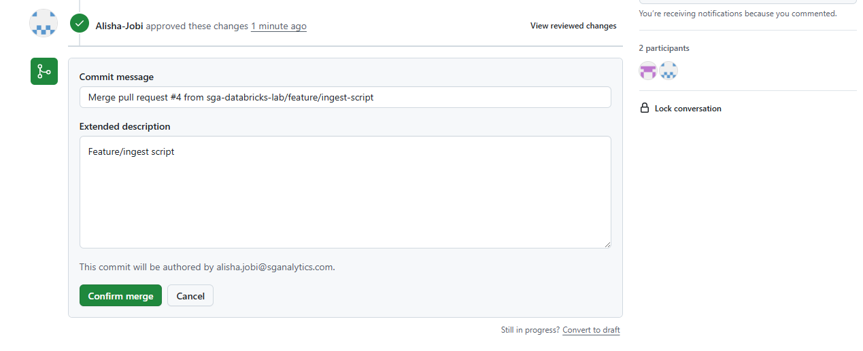

Important Note (If you are currently logged in as dishu5859):
Both PRs in the screenshot were created by dishu5859. GitHub does not allow you to approve your own pull request.
- To have a teammate approve it: Ask a teammate to log in to their own GitHub account and follow the steps above.
- If you are working alone and need to merge immediately:
  - Go to Repo Settings -> Branches.
  - Click Edit next to the main branch rule.
  - Temporarily uncheck "Require a pull request before merging" (or set Required approvals to 0) and click Save changes.
  - After this, the red warning on the PR page will disappear, allowing you to directly click the Merge pull request button.

- Once the merger request is approved, remove the file from the pull request and move all files into the main folder.
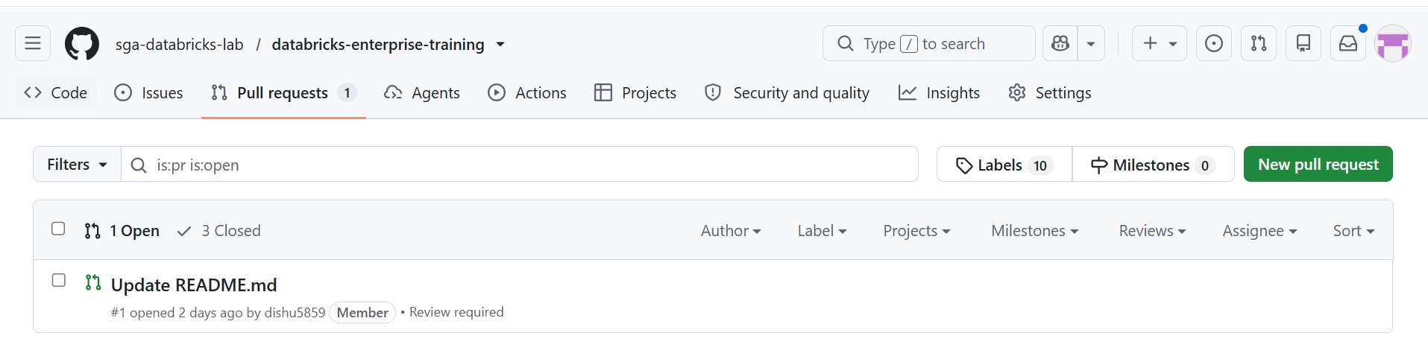
- After approved and merger you can now see all the files visible in the bronze layer.
